8.4

FIFO

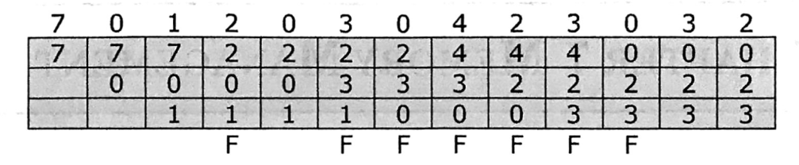

LRU

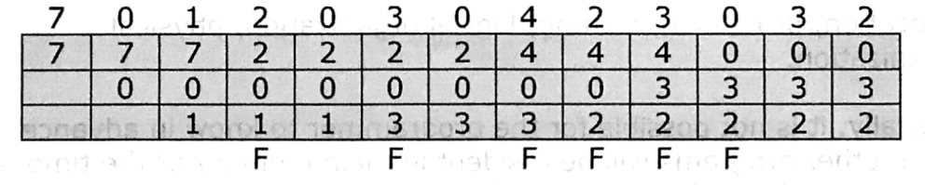

Clock

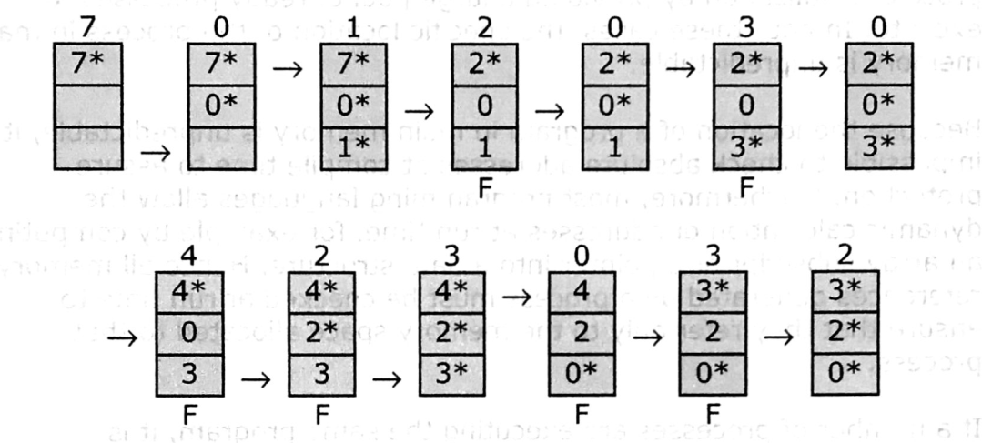

OPT

